Agreement approval process:
The document Elaborates the approval process of an agreement request in Vistex application.
Required setup:
- 3 different users with different roles (Business Accounting, Regional Accounting, Head Office).
Ex:
Amoolya – Business accounting
Prasad / Rishi – Regional Accounting
Raghunath – Head Office
- Recipient List needs to be updated with necessary entries of User.
Ex: Regional accounting screenshot
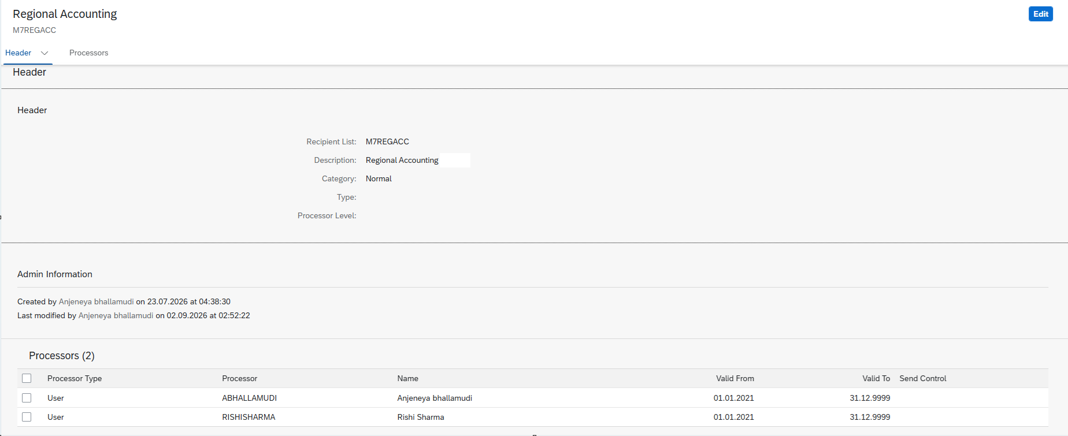

Create, Save and Submit of Agreement Request with Business Accounting User:
- Create agreement, with users having role as Business accounting.
- Click on Save and click on submit.
Note down the agreement - ______________ .
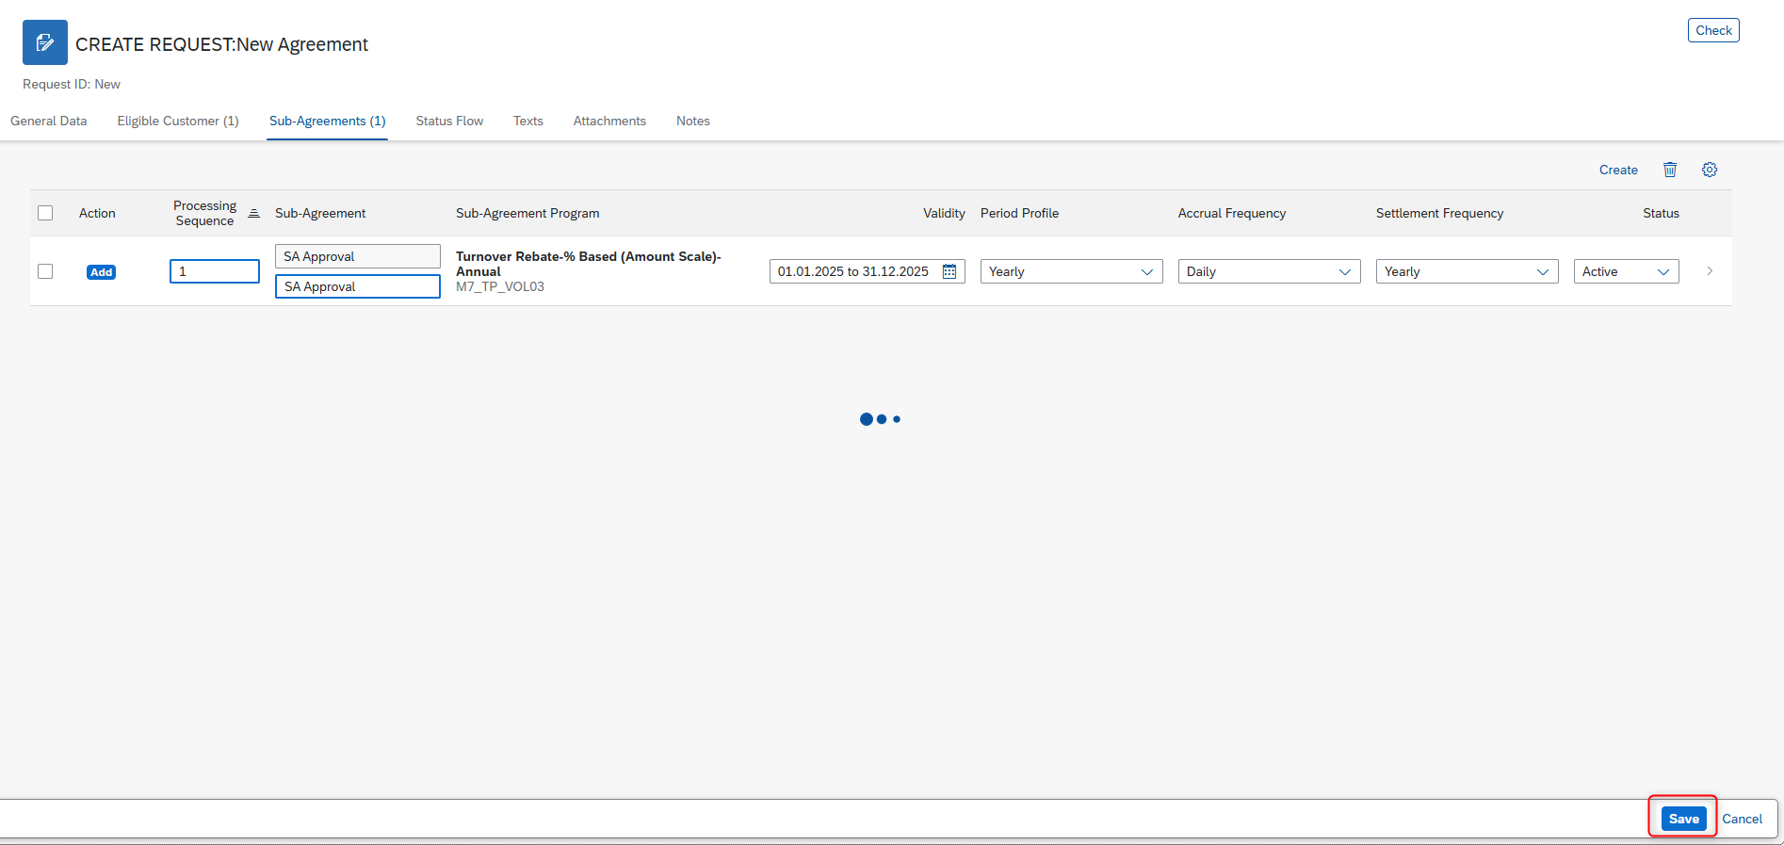

On clicking on save, an email will be sent to the business accounting user (user who created agreement), as submit reminder.
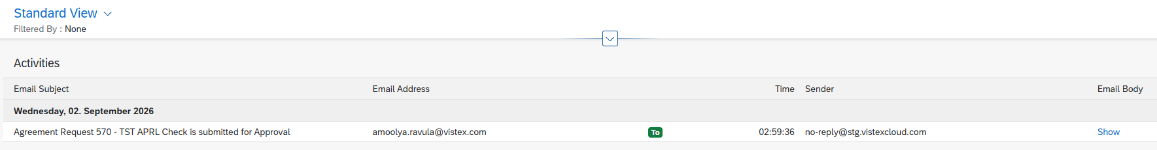
Email will be received with following subject. Regional Approval can navigate to respective agreement request by hyperlink.
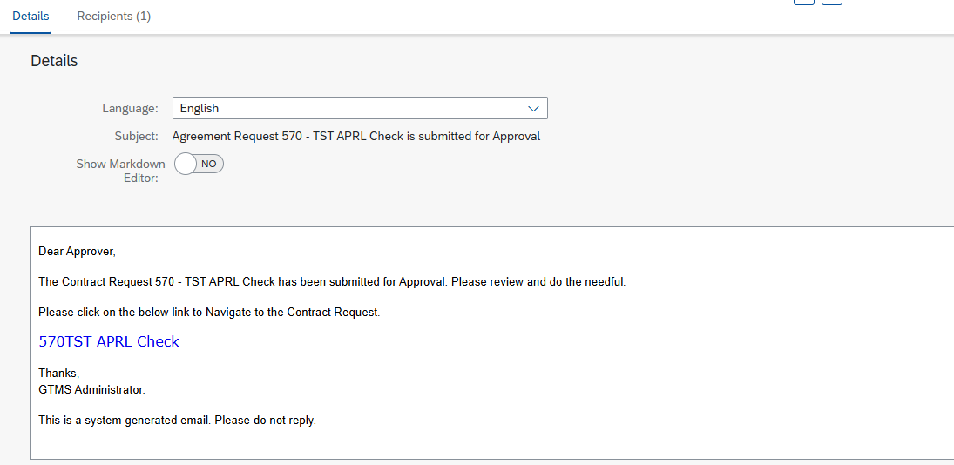

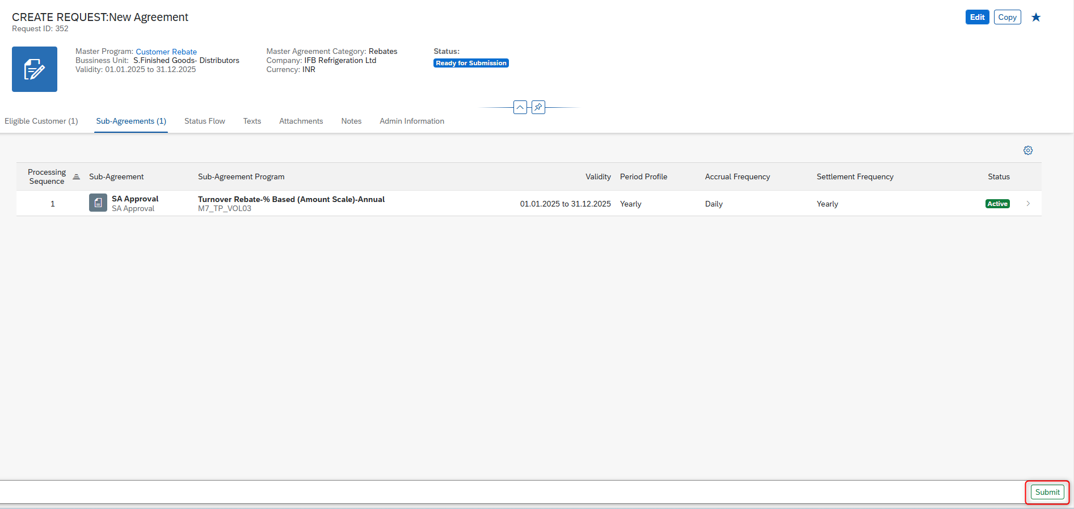

Note: After submitting of Agreement request, the initial approval can be done by regional accounting user only.

Initial Approval with Regional accounting User:
Login with Regional Accounting User.
Note: For now, Individual user must create a search variant to display respective region created agreement request present for approval
Open above created request and click on approve button. In the pop-up click on Approve.
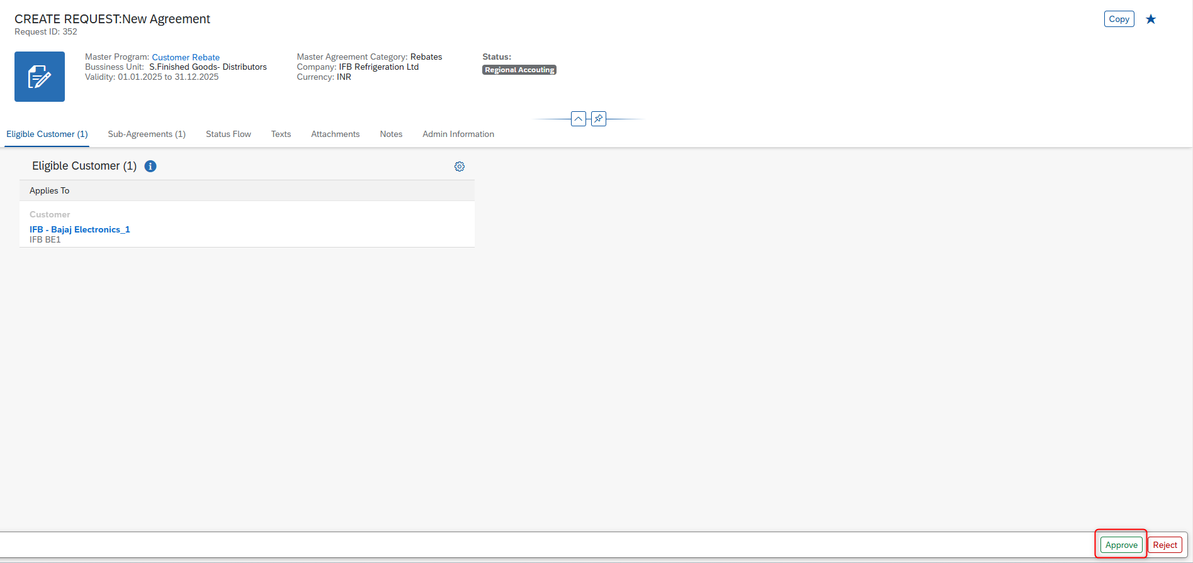
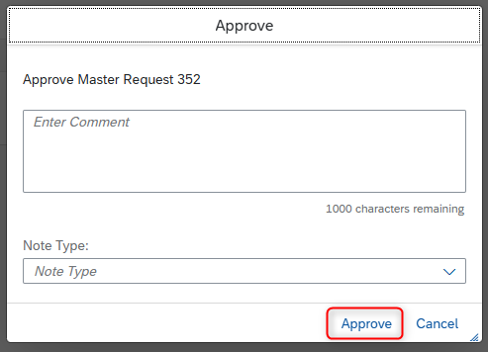
An email will be sent with Head office approval. After Regional account approval, the final approval can be done by Users having Head office Role only.
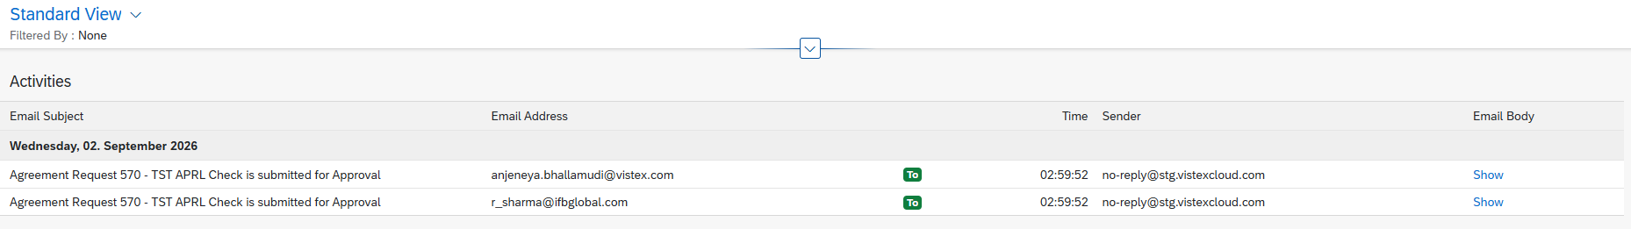
Email will be received with following subject. Head office Approval user can navigate to respective agreement requests by hyperlink.
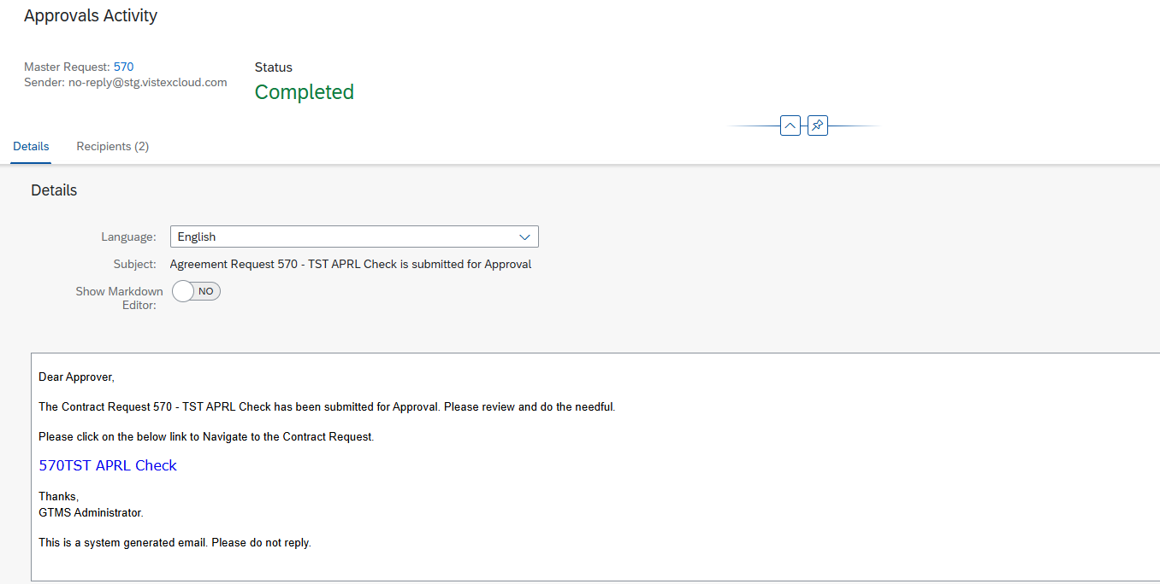

Final Approval of Agreement request:
Login with User having role as Head Office.
Note: For now, Individual user must create a search variant to display respective region created agreement request present for approval.
Open above created request and click on approve button. In the pop-up click on Approve.
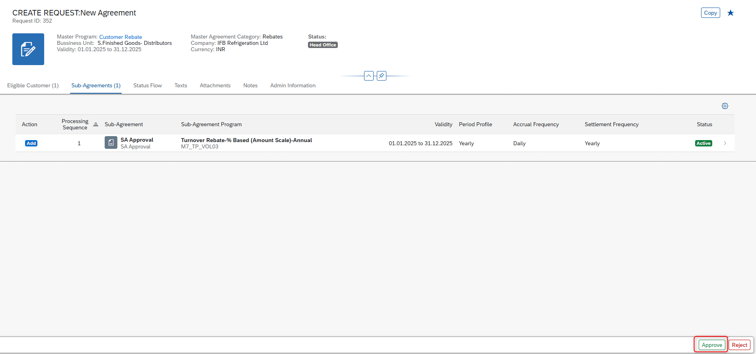
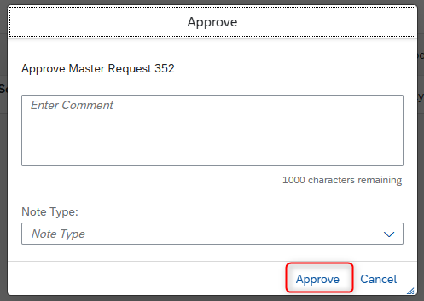
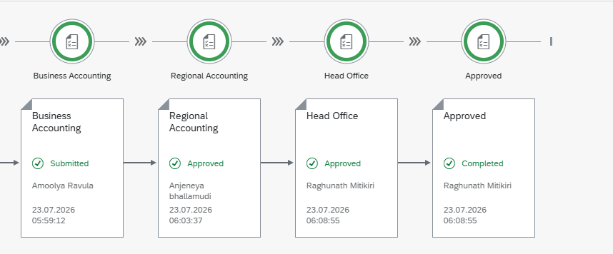

Upon head office approval, the request will be finally approved, and master agreement and sub agreement will be created. Can be viewed in respective lists accordingly.
An email will be triggered to agreement request created user mentioning the agreement is approved
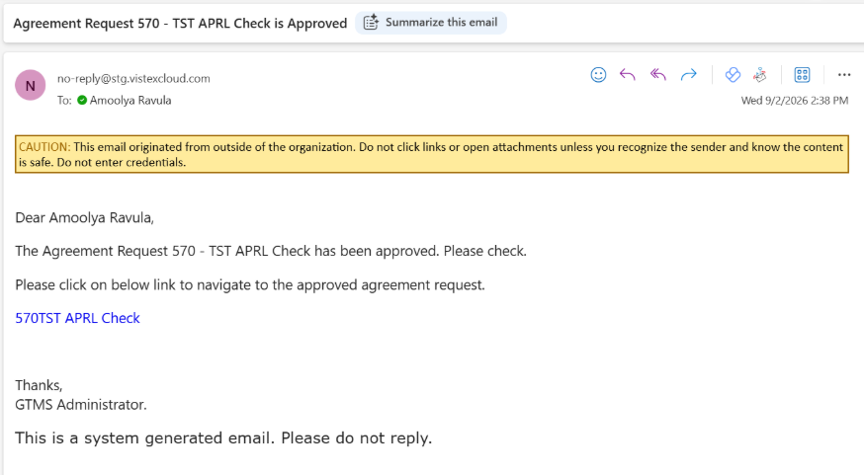

Reject Step:
In case at any level (Regional or head office), if agreement request is rejected, it will be moved to business accounting user (user who created respective agreement) for re-verifying and changes to be made.
An email similar will be triggered to business accounting user (agreement request created user)
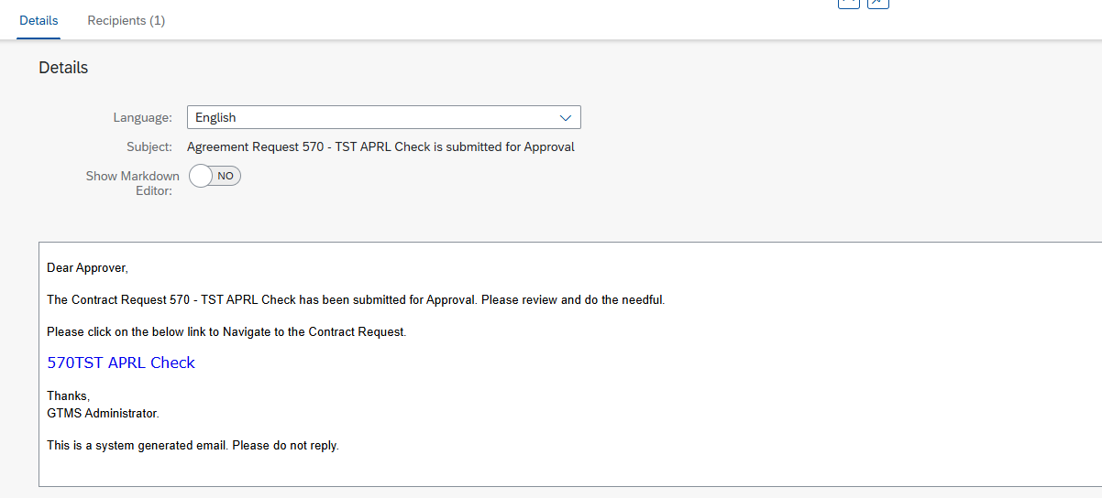
After making all necessary changes, the agreement must be flowed through series of approvals as mentioned above. The process remains same.
